Abstract
Microbes exhibit various metabolic profiles due to their long-term adaptation to varying resources. Saccharomyces yeast exhibits metabolic plasticity during a growth cycle by first fermenting its carbon source, followed by utilizing oxygen-driven respiration once the carbon is depleted. While it is well-studied that yeast can switch its gene expression profile from fermentative to respiratory metabolism in over a 2-day growth cycle, no studies have examined whether yeast adapting to fermentation-only or respiration-only growth can fine-tune its global transcriptome beyond this initially plastic response through evolution. To test for this, we utilized yeast strains from the Multicellularity Long-Term Evolution Experiment (the MuLTEE) at 1- and 1,000-day (5,000 generations) of growth solely through fermentation (as petite mutants) or respiration (by growing in non-fermentable glycerol) by comparing transcriptome profiles of those metabolic treatment groups to the mixotrophic ancestral control strains. Our results show that most of the gene expression in glycolysis, tricarboxylic acid cycle (TCA), and electron transport chain (ETC) pathways shifts readily when yeast switches from mixotrophic to fermentative or respiratory growth. Beyond this initial plastic response, evolutionary adjustment occurred exclusively in the respiration-only strain, where 13 ETC genes, particularly mitochondrial-encoded genes, had elevated transcript levels. These results suggest that yeast’s dominant fermentative life-history has already optimized fermentation, whereas extended respiratory evolution drives continued transcriptomic adaptation in the ETC pathway.

Introduction

Organisms can change their metabolism upon entering new environments, a phenomenon known as metabolic plasticity that enables adaption by switching substrates and energy-generating pathways (Dana et al., 2024). This involves rapid regulation of genes encoding metabolic enzymes. For instance, when S. cerevisiae switches from acetate to glucose, it adjusts its metabolism to initiate fermentation. Similarly, when E. coli depletes glucose and encounters lactose, it immediately expresses genes of the lac operon (Rothman et al., 2023). Such transcriptional responses enable metabolically adaptation without genetic change, a phenomenon known as transcriptomic plasticity (Bei et al. 2024). This is particularly evident in organisms with complex metabolic histories, such as the budding yeast, S. cerevisiae.

S. cerevisiae is a Crabtree positive organism, using energetically less efficient fermentation instead of respiration even in the presence of oxygen, compensating for low ATP yield through high glycolytic flux and rapid glucose consumption (Régimbeau et al., 2022). Proteomic studies of Crabtree positive yeasts reveal elevated levels of tricarboxylic acid (TCA) cycle, electron transport chain (ETC), and ATP synthase proteins, consistent with increased glycolytic flux (Malina et al., 2021). Additionally, transcriptome and proteome studies of aerobic and anaerobic glucose-limited chemostat cultures demonstrate post-transcriptional regulation of glycolysis and glycolytic proteins in anaerobes (de Groot et al., 2007). While previous studies have captured immediate responses, there is no study testing whether an extended evolution of obligate fermentation and respiration drive further transcriptional evolution. By examining genes responsible for major carbon metabolism genes, one can determine whether yeast's Crabtree-positive life history provides sufficient plasticity or whether additional evolution fine-tuning occurs under prolonged obligatory metabolism for either fermentation or respiration.
To study this, we used yeast strains from the Multicellularity Long-Term Evolution Experiment (MulTEE). Ancestral snowflake yeast were evolved under three metabolic conditions: mixotrophic (PM, facultative control growing in glucose), respiratory (PO, growing through in non-fermentable glycerol), and fermentative (PA, a petite mutant with defective mitochondria growing in glucose). Five replicate populations of each metabolic treatment evolved for 5,000 generations (1,000 days) with 24-hour growth cycles followed by settling selection for multicellular size (Bozdag et al., 2021). To distinguish plastic from evolved gene expression differences in central carbon metabolism, we sequenced transcriptomes of ancestral and evolved isolates from the PA and PO treatments (clonal isolates from PA5 and PO5 populations at generation 5,000), comparing all strains to the mixotrophic ancestor (PM-ancestor). We calculated plastic responses as gene expression differences between fermentative and respiratory ancestors against the mixotrophic control (PA-ancestor vs. PM-ancestor and PO-ancestor vs. PM-ancestor), and plastic + evolved responses as differences between evolved strains and the mixotrophic control (PA5-t1000 vs PM-ancestor and PO5-t1000 vs PM-ancestor). By subtracting plastic responses from plastic + evolved responses, we isolated evolutionary changes occurring beyond the initial plastic adjustment, revealing whether 5,000 generations of obligate metabolism drove further transcriptional refinement
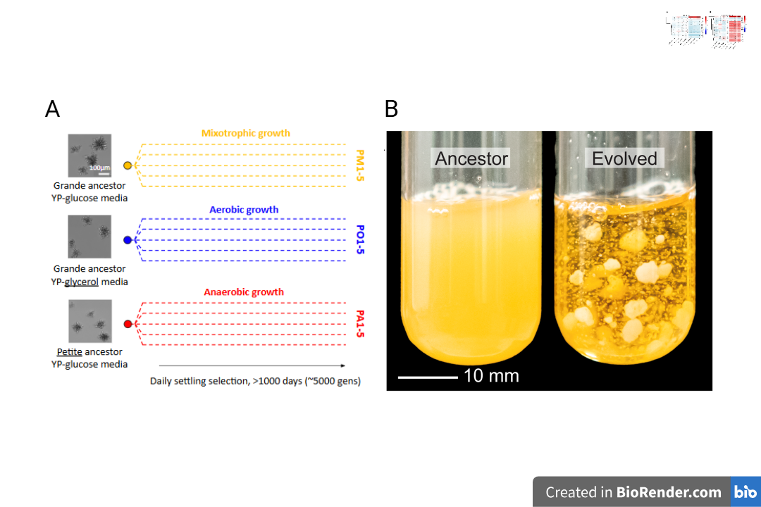
Figure 1. The Multicellularity Evolution Experiment growing yeast through different carbon metabolism. (A) Ancestral grande snowflake yeast evolved through either mixotrophic metabolism (PM1-5 populations, grown in YEPD) or obligately respiratory metabolism (PO1-5 populations, grown in YEPG). From this grande ancestor, we also generated a petite mutant incapable of oxygen-driven respiration, growing solely through fermentative metabolism (PA1-5 populations, grown in YEPD). All populations underwent a 24-hour growth cycle followed by size-based settling selection over 1,000 transfers (5,000 generations). From these evolved populations, we utilized a single strain isolate from each of the PO5, PM5, and PA5 evolved populations and their corresponding ancestral strains after 24 hours of growth to obtain RNA for transcriptome sequencing. (B) PA populations evolved macroscopic multicellular clusters, whereas PM and PO populations remained microscopic due to limited oxygen concentration (Bozdag et al. 2021, Nat. Commun.; figure adapted from Bozdag et al. 2023, Nature).

Results
First, we examined RNA-sequencing results to uncover plastic gene expression differences, defined as immediate gene expression changes when yeast switches to either fermentative or respiratory growth from its natural state of facultative metabolism, without any evolutionary adaptation. Specifically, we ran DESeq2 to calculate log2 fold changes in gene expression using Illumina sequence reads analyzed by SALMON relative to the common control strain (facultative ancestral strain, GOB8). Differential expression was determined using Wald test p-values adjusted for multiple testing by the Benjamini-Hochberg method (padj < 0.05).
In ancestral petite yeast cells containing deleterious mutations in their mitochondrial DNA, the glycolytic pathway did not show an overall significant changes, with only a mean log2 fold change of -0.24 across 11 genes (Fig. 2, reactions from Glucose to Pyruvate, circles labeled as 'F'), the expression of genes for citric acid cycle (TCA or tricarboxylic acid cycle) and oxygen-driven respiration was generally repressed (Figure 2, circles labeled with the letter 'F'). In contrast, genes encoding the transport of pyruvate into mitochondria, as well as 5 out of 8 TCA genes in the later steps of the cycle, were significantly downregulated compared to the facultative control strain (p < 0.0000001), matching previous work on metabolite and proteome level changes (Vowinckel et al. 2021). Notably, a few early TCA cycle genes are upregulated in petites, potentially supporting the finding that essential anabolic functions are still stimulated by early TCA cycle reactions (Epstein et al. 2001; Vowinckel et al. 2021).
In respiratory yeast growing in non-fermentable carbon (glycerol), there was significant plastic change in gene expression compared to the isogenic control strain growing on glucose. Specifically, growth on non-fermentable carbon resulted in reduced glycolytic gene expression with a mean of -1.78 log2 fold change across 11 genes (blue circles labeled as 'R' in Fig 2, showing downregulation), whereas there was significant upregulation of TCA cycle genes with a mean of 2.14 log2 fold change (red circles labeled as 'R' in Fig 2, showing upregulation). The increase in TCA cycle expression was accompanied by significant upregulation of MPC1 and MPC3 with a mean of 3.75 log2 fold change, showing increased pyruvate uptake into mitochondria. This pattern of decreased glycolytic gene expression followed by increased TCA cycle gene expression is common across other yeast strains grown on non-fermentable carbon or after switching from fermentative to respiratory growth during a growth cycle, measured through metabolite production rates and changes in gene expression or protein levels (DeRisi et al. 1997 Science; Ferea et al. 1999 ; Kolkman et al. 2005; Daran-Lapujade et al. 2007).
Together, these results demonstrate that both respiratory and fermentative yeast exhibit significant changes in carbon metabolism gene expression (for glycolysis, fermentation, and tricarboxylic acid cycle) immediately after transitioning to either metabolic condition, without experiencing adaptive evolution under these two conditions.

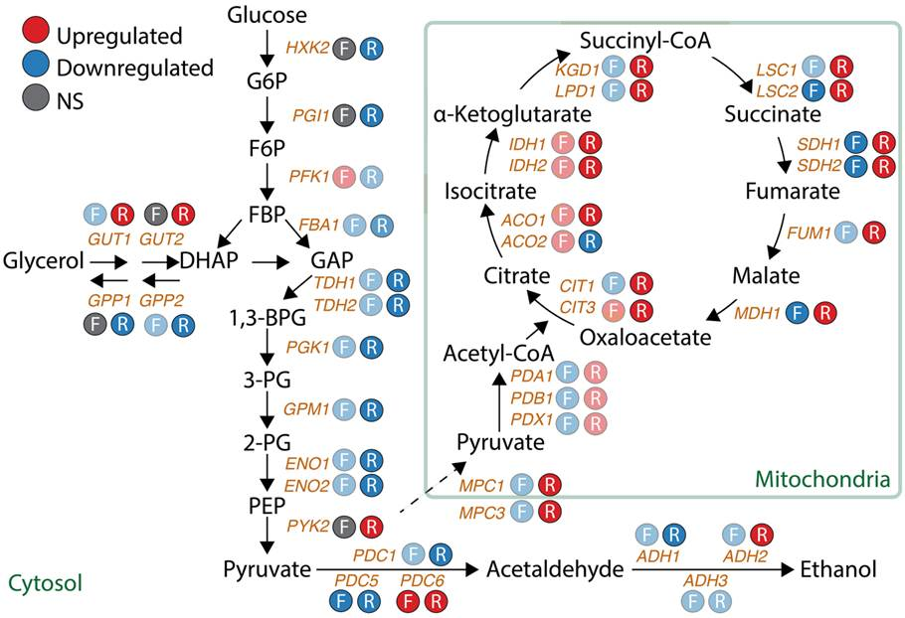
Figure 2. Plastic gene expression changes in central carbon metabolism upon transition to obligate fermentation or respiration. Differential expression of glycolysis, fermentation, and TCA cycle genes in ancestral petite (F, fermentative) and respiratory (R) yeast relative to the facultative control strain. Red circles indicate significant upregulation; blue circles indicate significant downregulation; grey circles indicate no significant change (padj < 0.05, Benjamini-Hochberg corrected). Fermentative yeast show minimal changes in glycolytic genes but downregulation of late TCA cycle steps, while respiratory yeast show coordinated downregulation of glycolysis and upregulation of TCA cycle and pyruvate transport genes.
Distinguishing plastic from evolved responses in metabolic gene expression
Next, we explored whether yeast further adjust their metabolic gene expression when evolved consistently under fermentative or respiratory-only metabolism, to determine whether transcriptome levels are further adjusted evolutionarily or whether the plastic response observed in their ancestors was sufficient. To do this, we compared fold-expression differences (log2 fold change) for ancestral strains (fermentative or respiratory yeast vs. facultative control), and strains evolved for 1,000 generations under each metabolism (vs. the same facultative control), for each pathway before and after evolution (Table 1). The first finding is that the direction of gene expression change (downregulation or upregulation) in ancestral and evolved strains was the same across all 14 comparisons (7 pathways and two metabolic treatments, respiratory or fermentative vs. the common facultative control). This suggests that the immediate gene expression response pattern, regardless of magnitude, remained in the same direction after evolution, with no reversals from downregulation to upregulation or vice versa, suggesting the ancestral plastic response was directionally beneficial for metabolic adjustment rather than an immediate stochastic response. However, this analysis does not reveal whether there is additional evolutionary adjustment in gene expression beyond the initial plastic response.
Metabolic Pathway | Fermentative Ancestral | Fermentative Evolved | Respiratory Ancestral | Respiratory Evolved
Glycolysis | -0.24 ¬± 0.26 | -0.45 ¬± 0.34 | -1.78 ¬± 1.52 | -1.61 ¬± 1.10
Glycerol entry | -0.44 ¬± 0.40 | -0.32 ¬± 0.22 | 0.58 ¬± 4.52 | 0.60 ¬± 4.85
Fermentation | -0.40 ¬± 1.23 | -0.72 ¬± 1.38 | -0.87 ¬± 2.83 | -0.68 ¬± 2.65
Pyruvate entry | -0.87 ¬± 0.31 | -0.37 ¬± 0.56 | 3.75 ¬± 1.54 | 3.47 ¬± 1.21
TCA Cycle | -0.36 ¬± 0.86 | -0.56 ¬± 0.72 | 2.14 ¬± 2.09 | 2.35 ¬± 1.53
ETC (mt-DNA) | -5.34 ¬± 1.72 | -5.33 ¬± 1.72 | 1.25 ¬± 0.73 | 2.18 ¬± 0.80
ETC (nuclear) | -0.67 ¬± 0.39 | -0.82 ¬± 0.31 | 2.42 ¬± 0.48 | 2.68 ¬± 0.55
Table 1. Average metabolic gene expression changes under fermentative and respiratory selection. Mean log2 fold change (± s.d.) for genes in each metabolic pathway, comparing ancestral and evolved strains to the facultative ancestor (GOB8). Ancestral values represent plastic responses upon immediate metabolic switch (fermentative: GOB21 vs GOB8; respiratory: Gly vs GOB8). Evolved values represent relative gene expression changes after 1,000 generations of selection compared to the same facultative ancestor (fermentative: PA5_t1000 vs GOB8; respiratory: PO5_t1000_S vs GOB8). For each pathway, n represents the number of genes analyzed (Glycolysis: n = 11; Glycerol entry: n = 4; Fermentation: n = 6; Pyruvate entry: n = 2; TCA Cycle: n = 17; ETC (mt-DNA): n = 3; ETC (nuclear): n = 19).

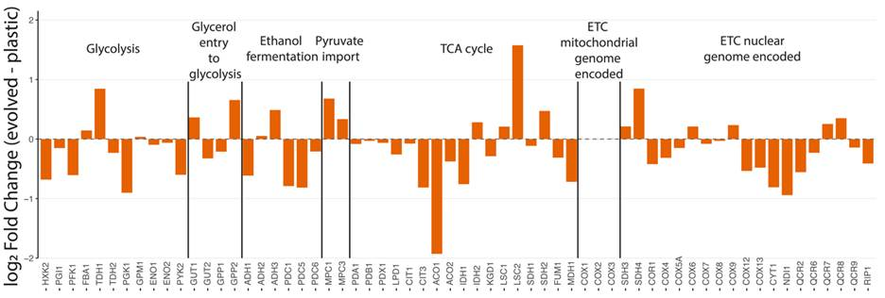
Figure 3. Evolutionary change in metabolic gene expression shows adjustment under fermentative growth through plastic responses. Evolutionary change in metabolic gene expression under fermentative selection, calculated by subtracting plastic response log2FC (GOB21 vs GOB8) from plastic+evolved response log2FC (PA5_t1000 vs GOB8). Genes are grouped by metabolic pathways. One-sample t-tests showed no significant evolutionary change in any pathway (one-sample t-tests, all p > 0.05), indicating metabolic adjustment to fermentative growth occurred mainly through plastic responses.
To distinguish plastic from evolved responses in metabolic gene expression, next we calculated evolutionary change by subtracting plastic responses (gene expression changes in the ancestral strains vs. the common facultative control) from plastic and evolved responses combined (i.e., gene expression changes in the evolved strains after 1,000 generations vs. the common facultative control). Under fermentative growth, the switch from facultative to fermentative metabolism in the ancestral strain resulted in downregulation of glycolysis genes (mean log2FC = -0.24 across 11 genes) and fermentation genes (mean log2FC = -0.40 across 6 genes), while mitochondrial electron transport chain genes showed severe downregulation (mt-DNA encoded: mean log2FC = -5.34; nuclear encoded: mean log2FC = -0.67). After 1,000 generations of fermentative evolution, however, gene expression patterns remained remarkably similar to the ancestral plastic response, with one-sample t-tests revealing no significant evolutionary change in any metabolic pathway (Fig. 3; all p > 0.05). This indicates that metabolic adjustment to fermentative growth occurred largely through plastic responses.

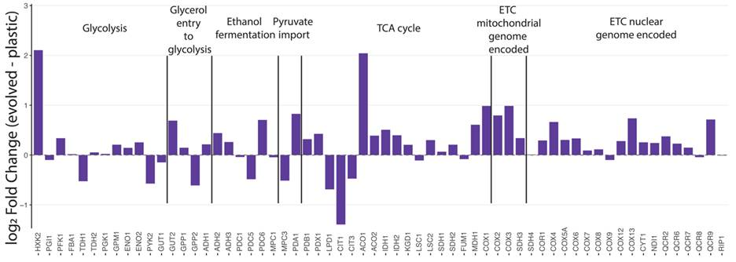
Figure 4. Evolutionary change under respiratory selection shows overexpressed ETC pathways beyond ancestral plastic upregulation. Evolutionary change in metabolic gene expression under respiratory selection, calculated by subtracting plastic response log2FC (Gly vs GOB8) from plastic+evolved response log2FC (PO5_t1000_S vs GOB8). Genes are grouped by metabolic pathways. One-sample t-tests showed significant evolutionary change in mitochondrial electron transport chain gene expression for both mitochondrial genome encoded (mean = +0.92 log2FC, p = 0.0047) and nuclear genome encoded (mean = +0.26 log2FC, p = 0.0002) genes, indicating these pathways were further overexpressed through evolution beyond their ancestral plastic upregulation. Other pathways showed no significant evolutionary change (one-sample t-tests, all p > 0.05).
Under respiratory growth, the switch to respiratory metabolism produced contrasting expression patterns: glycolysis genes were strongly downregulated (mean log2FC = -1.78 across 11 genes), while oxidative metabolism genes were upregulated, particularly in the TCA cycle (mean log2FC = 2.14 across 17 genes) and electron transport chain (mt-DNA encoded: mean log2FC = 1.25; nuclear encoded: mean log2FC = 2.42). After 1,000 generations of adaptation under respiratory metabolism, most pathways maintained their ancestral plastic responses without significant evolutionary change (Fig. 4, glycolysis p = 0.42, TCA cycle p = 0.25, fermentation p = 0.32). However, mitochondrial electron transport chain genes showed further upregulation beyond the plastic response, with mt-DNA encoded electron transport chain (ETC or oxidative phosphorylation) genes increasing by a mean of 0.92 log2FC (p = 0.0047) and nuclear encoded ETC genes by 0.26 log2FC (p = 0.0002), indicating these pathways underwent further evolutionary optimization for respiratory metabolism beyond their ancestral plastic upregulation.
Discussion
Saccharomyces yeast are Crabtree-positive, preferentially fermenting glucose through glycolysis and ethanol production, followed by a diauxic shift to oxidative respiration once glucose is depleted (Figure 3). While previous work has explored how yeast can fine-tune their metabolic transcriptome when constrained to fermentation-only or respiration-only growth, whether long-term adaptation further refine these changes remains unexplored. We addressed this by comparing transcriptomes of ancestral yeast switched to obligately fermentation or respiration, and examined further adjustments after 5,000 generations of adaptation. The direction and magnitude of initial gene expression changes remained largely similar after 5,000 generations for both treatments, particularly for glycolysis and TCA cycle genes, suggesting initial plasticity sufficiently supports these metabolic modes. The one exception involved electron transport chain (ETC) genes, which generate the electrochemical gradient driving ATP synthesis. Respiratory-evolved strain (PO5-t1000) showed further upregulation of both nuclear- and mitochondrial-encoded ETC genes, suggesting adaptation for more efficient ATP production from non-fermentable carbon.
Our transcriptomics results for glycolysis, fermentation, TCA cycle, and ETC in obligately respiratory yeast closely parallel previous work examining the transition from fermentative to respiratory metabolism. DeRisi et al. (1997), tracking gene expression during a 21-hour diauxic shift in glucose batch culture, observed downregulation of glycolytic genes and upregulation of TCA cycle genes, consistent with both our ancestral and evolved strains. Similarly, Ferea et al. (1999) evolved yeast for 250–500 generations in glucose-limited chemostats and found that fermentative populations transitioned toward respiratory metabolism, with decreased glycolytic gene expression and increased TCA cycle gene expression. The agreement across these studies, despite different strains and carbon sources for respiratory growth, suggests these transcriptional responses to respiratory metabolism are robust features of Crabtree-positive yeast. Differently from these earlier studies, we extended evolution to 5,000 generations, testing for transcriptomic fine-tuning beyond the initial plastic response. While glycolytic and TCA cycle genes showed no further fine-tuning, ETC genes from both mitochondrial and nuclear genomes underwent further upregulation (mitochondrial-encoded ETC genes: +0.92 log₂FC, p = 0.0047; nuclear-encoded ETC genes: +0.26 log₂FC, p = 0.0002). This provides, to our knowledge, the first demonstration that yeast can evolutionarily optimize electron transport chain beyond the initial plastic response.
When our ancestral yeast transitioned to obligate fermentation as petites (lacking functional mitochondria capable of oxygen-driven energy generation), genes for pyruvate transport into the mitochondrial matrix and the final five steps of the TCA cycle were significantly downregulated. Intriguingly, genes encoding the first two TCA cycle reaction steps (ACO1, ACO2, IDH1, IDH2), which produce isocitrate and α-ketoglutarate, were slightly upregulated. This counterintuitive result parallels protein-level differences reported by Vowinckel et al. (2021) in another petite yeast, who also detected elevated levels of these proteins. This suggests the products of these early TCA reactions support other mitochondrial and anabolic functions, explaining their upregulation despite the repression of final reactions in TCA cycle. Our 5,000-generation dataset uniquely allowed us to test whether prolonged evolution altered gene expression beyond the initial plastic response. Both TCA cycle gene expression and the near-complete silencing of mitochondrial-encoded ETC genes (COX1, COX2, COX3) remained unchanged. The near-zero expression of these genes in ancestral petites, maintained throughout evolution, suggests either deletion of these mitochondrial regions or transcriptional shutdown via a master regulator, requiring further investigation. Thus while the transition to obligately fermentation produced substantial plastic changes in carbon metabolism and mitochondrial gene expression, 5,000 generations of adaptation caused minimal further transcriptomic adjustment.
Our study demonstrates that carbon and mitochondrial energy metabolism genes are primarily regulated through plasticity rather than evolutionary fine-tuning, with the notable exception of ETC genes in respiratory-evolved yeast. This finding aligns with Rothman et al. (2020), who through flux-balance and metabolic-control analysis that metabolic adaptation relies heavily on the starting phenotype, with regulatory fine-tuning rather than de novo adaptation. While their study examined short-term physiological transitions, our 5,000-generation evolution experiment supports a complementary conclusion: the life history of Crabtree-positive yeast (i.e., rapid fermentative growth under high glucose followed by ethanol respiration after carbon depletion) has generated sufficient regulatory plasticity to modulate gene expression appropriately without substantial changes to baseline mRNA levels. However, our study cannot rule out protein-level changes evolving over 5,000 generations. As Muenzner et al. (2024) demonstrated in yeast with varying ploidy and aneuploidy, most dosage compensation occurs at the protein level while mRNA levels remain relatively stable. Thus, quantitative proteomics and metabolomics quantification is needed to determine whether similar post-transcriptional adaptation has occurred in our evolved populations.

Methods
3.1 S. cerevisiae cell cultures
We revived ancestral strains (PM, PO, and PA) and single strain isolates from 1,000-day evolved populations (PM5, PO5, and PA5) from -80°C glycerol stocks. We grew mixotrophic strains (PM ancestor and PM5) and anaerobic strains (PA ancestor and PA5) in YEPD medium (1% yeast extract, 2% peptone, 2% glucose), while we grew respiratory strains (PO ancestor and PO5) in YEPG medium (1% yeast extract, 2% peptone, 3% glycerol). All cultures were incubated at 30°C with shaking at 200 rpm for 48 hours to reach stationary phase prior to RNA extraction.
3.2 Gene expression analysis
We extracted total RNA using the MasterPure Yeast RNA Purification Kit (Madison, Wisconsin Cat. Nos. MPY03010 and MPY03100) following the manufacturer’s protocol and resuspended RNA in TE buffer. We quantified the RNA using spectrophotometry (A260/A280 ratio >2.0) and assessed concentration and purity using a Nanodrop spectrophotometer, ensuring the samples were free of DNA or protein contamination. We submitted the purified RNA samples to the Georgia Institute of Technology core facility for Illumina library preparation and Illumina sequencing using the Illumina HiSeq platform.
3.3 DESeq 2 pipeline
We performed bioinformatics analyses using R (V. 4.5.1) and RStudio (2025.05.1) (Allaire, J., 2012. RStudio: integrated development environment for R. Boston, MA, 770(394), pp.165-171). We used the packages Biocmanager and DESeq2 for further analysis and normalization. The data from the first round was imported, and 4 GOB21 (PA), 3 GOB8_Gly (PO), and 4 GOB8 (PM/control) were subset. Samples included 3-4 technical replicates of the PO ancestor (GOB8, glycerol), the PA ancestor (GOB21, petite mutant), and the PM ancestor (GOB8, mixotrophic control) as well as a single clonal isolate from each of these metabolic treatment groups collected after a 1000-day evolution. First, we removed genes with lower than 10 reads. Next, we ran the DESEq2 relative expression analysis comparing all ancestral and evolved samples against the PM-ancestral control. Using a significance threshold of ⍺ = 0.05, we extracted the results into.csv files, containing the gene names, log₂ fold change, and p-value adjusted for multiple testing. This generated 5 pairwise comparisons, PA-ancestor vs. PM-ancestor, PO-ancestor vs. PM-ancestor, PM-t1000 vs. PM-ancestor, PA-t1000 vs. PM-ancestor, and PO-t1000 vs. PM-ancestor. All scripts are available at https://github.com/gilliantorrencemyers-droid/Undergraduate-Research-2023-2026.git.
3.4 Pathway enrichment analysis
We used the csv files to identify significantly expressed genes linked to specific metabolic pathways by utilizing the following R packages: Bioconductor, tibble, tidyverse, KEGGREST, yeast genome database (CITE) and clusterProfiler. We subset genes with an adjusted p-value < 0.05 and created a vector containing the corresponding log₂fold changes. We conducted a Kegg Pathway Enrichment analysis (p-value < 0.05, q-value < 0.10) and a Kegg Module Analysis to examine broader functional enrichment (p-value < 1, q-value <1), displaying the top 10 groupings. To perform the GO (gene ontology) analysis, we generated a vector of log2 fold changes with the corresponding ENTREZIDs and conducted GO Enrichment analysis (p-value < 0.05, q-value < 0.10) for molecular functions. All scripts are available at https://github.com/gilliantorrencemyers-droid/Undergraduate-Research-2023-2026.git.
3.5 Statistical analysis of metabolic gene expression evolution
To distinguish plastic from evolved gene expression responses, we calculated evolutionary change as the difference between plastic+evolved and plastic responses for each gene. For fermentative evolution, we subtracted the plastic response (PA-ancestor vs PM-ancestor) from the plastic + evolved response (PA5_t1000 vs PM-ancestor). For respiratory evolution, we subtracted the plastic response (PO-ancestor vs PM-ancestor) from the plastic + evolved response (PO5-t1000_S vs PM-ancestor). This subtraction yields the additional log2 fold change attributable to evolutionary adaptation beyond the immediate plastic response. We tested whether evolutionary change was significantly different from zero for each metabolic pathway using one-sample t-tests. We performed tests separately for fermentative and respiratory conditions, with genes grouped by metabolic pathway (Glycolysis, TCA Cycle, etc.). We assessed significance at α = 0.05.

References
Bei, C., Zhu, J., Culviner, P. H., Gan, M., Rubin, E. J., Fortune, S. M., Gao, Q., & Liu, Q. (2024). Genetically encoded transcriptional plasticity underlies stress adaptation in Mycobacterium tuberculosis. Nature Communications, 15, 3088. https://doi.org/10.1038/s41467-024-47410-5
de Groot, M. J. L., Daran-Lapujade, P., van Breukelen, B., Knijnenburg, T. A., de Hulster, E. A. F., Reinders, M. J. T., Pronk, J. T., Heck, A. J. R., & Slijper, M. (2007). Quantitative proteomics and transcriptomics of anaerobic and aerobic yeast cultures reveals post-transcriptional regulation of key cellular processes. Microbiology, 153(11), 3864–3878. https://doi.org/10.1099/mic.0.2007/009969-0
DeRisi, J. L. (1997). Exploring the Metabolic and Genetic Control of Gene Expression on a Genomic Scale. Science, 278(5338), 680–686. https://doi.org/10.1126/science.278.5338.680
Epstein, C. B., Waddle, J. A., Hale, W., Davé, V., Thornton, J., Macatee, T. L., Garner, H. R., & Butow, R. A. (2001). Genome-wide Responses to Mitochondrial Dysfunction. Molecular Biology of the Cell, 12(2), 297–308. https://doi.org/10.1091/mbc.12.2.297
Ferea, T. L., Botstein, D., Brown, P. O., & Rosenzweig, R. F. (1999). Systematic changes in gene expression patterns following adaptive evolution in yeast. Proceedings of the National Academy of Sciences, 96(17), 9721–9726. https://doi.org/10.1073/pnas.96.17.9721
Jakob Vowinckel, Hartl, J., Marx, H., Kerick, M., Runggatscher, K., Keller, M. A., Mülleder, M., Day, J., Weber, M., Rinnerthaler, M., Yu, J., Simran Kaur Aulakh, Lehmann, A., Diethard Mattanovich, Timmermann, B., Zhang, N., Dunn, C. D., MacRae, J. I., Breitenbach, M., & Ralser, M. (2021). The metabolic growth limitations of petite cells lacking the mitochondrial genome. Nature Metabolism, 3(11), 1521–1535. https://doi.org/10.1038/s42255-021-00477-6
Malina, C., Yu, R., Björkeroth, J., Kerkhoven, E. J., & Nielsen, J. (2021). Adaptations in metabolism and protein translation give rise to the Crabtree effect in yeast. Proceedings of the National Academy of Sciences, 118(51), e2112836118. https://doi.org/10.1073/pnas.2112836118
MasterPure Yeast RNA Purification Kit | LGC, Biosearch Technologies. (2025). Biosearchtech.com. (n.d.).
Muenzner, J., Trébulle, P., Agostini, F., Henrik Zauber, Messner, C. B., Steger, M., Kilian, C., Lau, K., Barthel, N., Lehmann, A., Textoris-Taube, K., Elodie Caudal, Egger, A.-S., Amari, F., Chiara, M. D., Vadim Demichev, Gossmann, T. I., Mülleder, M., Gianni Liti, & Schacherer, J. (2024). Natural proteome diversity links aneuploidy tolerance to protein turnover. Nature, 630(8015), 149–157. https://doi.org/10.1038/s41586-024-07442-9
Ratcliff, W. C., Fankhauser, J. D., Rogers, D. W., Greig, D., & Travisano, M. (2015). Origins of multicellular evolvability in snowflake yeast. Nature Communications, 6(1). https://doi.org/10.1038/ncomms7102
Régimbeau, A., Budinich, M., Abdelhalim Larhlimi, José, J., Olivier Aumont, Laurent Memery, Bowler, C., & Eveillard, D. (2022). Contribution of genome‐scale metabolic modelling to niche theory. Ecology Letters, 25(6), 1352–1364. https://doi.org/10.1111/ele.13954
Rothman, D. L., Moore, P. B., & Shulman, R. G. (2023). The impact of metabolism on the adaptation of organisms to environmental change. Frontiers in Cell and Developmental Biology, 11. https://doi.org/10.3389/fcell.2023.1197226
Rothman, D. L., Stearns, S. C., & Shulman, R. G. (2020). Gene expression regulates metabolite homeostasis during the Crabtree effect: Implications for the adaptation and evolution of Metabolism. Proceedings of the National Academy of Sciences, 118(2). https://doi.org/10.1073/pnas.2014013118

